

JBEAM Installation Guide

Version

Table of Contents

1 Introduction 4

1.1 Pre-Requisites 4

1.2 Installation Overview 5

1.2.1 One-Is-To-One 5

1.2.2 One-Is-To-Many 6

1.2.3 Considerations 6

2 Install JBEAM 7

2.1 MONITOR-COMM 7

2.1.1 Create OS User 7

2.1.2 Download 7

2.1.3 Unzip / Extract 8

2.1.4 Update Properties 8

2.1.5 Create Schema 8

2.1.6 Execute SQLScripts 9

2.1.7 Start 9

2.1.8 Verify 10

2.2 CORE-COMM 11

2.2.1 Create OS User 11

2.2.2 Download 11

2.2.3 Unzip 11

2.2.4 Update Properties 12

2.2.5 Create Schema 12

2.2.6 Execute SQL Scripts 13

2.2.7 Start 13

2.2.8 Verify 13

2.3 PRE / JBEAM Core 15

2.3.1 Create OS User 15

2.3.2 Download Release 15

2.3.3 Unzip 16

2.3.4 Update Properties 17

2.3.5 Update Scripts 20

2.3.6 Create Schema 20

2.3.7 Execute SQL Scripts 20

2.3.8 Start PRE 21

2.3.9 Verify 21

2.4 Monitor Services 22

2.4.1 Create OS User 22

2.4.2 Download 22

2.4.3 Unzip or Extract 23

2.4.4 Update Properties 23

2.4.5 Create Schema 24

2.4.6 Execute SQL Scripts 24

2.4.7 Start the Service 24

2.4.8 Verify 25

2.5 JBEAM AIR Installation 26

2.5.1 Download the JBEAM-5.6.0.air file. 26

2.5.2 Install 27

2.5.3 Install Jbeam-5.6.0.AIR. 27

2.5.4 Configure the server. 30

2.6 PLUG-INs 32

2.6.1 Download plug-ins 32

2.7 Deploy Project Specific Resources 33

2.7.1 SQL Scripts 33

2.7.2 JAR Files 33

2.7.3 Properties 33

3 Appendix 35

3.1 PRE Verification 35

# Introduction

The purpose of this document is to explain the installation process of the JBEAM suite for ICD. This document, in a step by step format explains the deployment process of the following JBEAM components:-

1. PRE 🡪 Process Request Engine which is responsible to execute the JBEAM core.
2. Core-Comm 🡪 Core communication module responsible to transmit data to one and only one monitor-comm.
3. Monitor-Comm 🡪 Monitor communication module responsible to do handshakes with multiple core-comm.
4. Monitor-Services 🡪 Responsible to do handshakes with the desktop JBEAM UI application
5. JBEAM UI 🡪 The user interface for JBEAM.
6. Plug-ins 🡪 For database compatibility plug-ins are introduced for each java component.

The document explains how to install JBEAM as well as how to upgrade the existing JBEAM to a newer release.

## Pre-Requisites

In order to install all the above components following pre-requisites needs to be satisfied.

|  |  |  |
| --- | --- | --- |
| Environment | Developed | Minimum |
| Sun JAVA | 1.6.0.14 | 1.6.0.14+ |
| Oracle | 10.2.0.4 | 10.2.0.4 |
| OJDBC Driver | ojdbc14.jar | [1]Ojdbc14.jar |
| BIRT Report Runtime | 3.7.2 | 3.7.2 or above  <http://download.eclipse.org/birt/downloads/> |
|  |  |  |

## Installation Overview

There are in all 5 components of JBEAM. They are JBEAM Core, Core-Comm, Monitor-Comm, Monitor-Services and JBEAM UI. PRE and Core-Comm together is called the CORE installation of JBEAM. Whereas the Monitor-Services and Monitor-Comm together is called as the MONITOR installation. There are two installation considerations that must be considered before we commence the actual installation steps. They are namely One-Is-To-One and One-Is-To-Many. Each of these is explained below.

### One-Is-To-One

When the MONITOR is configured to only one and one CORE then this installation is typically called as One-Is-To-One installation. The typical deployment diagram is as follows:

CORE

CORE-COMM

PRE (CORE)

APP SCHEMA

BPMS_CORE

MONITOR

MONITOR-SERVICES

MONITOR-COMM

BPMS_MONITOR

JBEAM UI

### One-Is-To-Many

When the MONITOR is configured to more than one CORE then this installation is typically called as One-Is-To-Many installation. The typical deployment diagram is as follows:

CORE

CORE-COMM

PRE (CORE)

APP SCHEMA

BPMS_CORE

MONITOR

MONITOR-SERVICES

MONITOR-COMM

BPMS_MONITOR

JBEAM UI

CORE

CORE-COMM

PRE (CORE)

APP SCHEMA

BPMS_CORE

Web Services

Web Services

### Considerations

In production it is recommended to have one MONITOR with one CORE but in non-production sites one MONITOR may talk with multiple CORE environments. The risk in having one MONITOR with multiple CORE is that if the MONITOR is down then the instructions cannot be transmitted to any CORE registered with it and vice-versa.

# Install JBEAM

Over all installation of JBEAM consists of the installing following components. The arrow indicates which phase you are in and each phase is then sub divided into its own installation steps or activities that need to be performed.

## MONITOR-COMM

The activities involved in installation of monitor-comm are as shown below. The following sections will guide you through the setup of monitor-comm.

### Create OS User

Create OS user say ‘jbeam’. We will use this user to install all the components of JBEAM. Also create a directory say ‘jbeam’. We will install all our components in this directory.

### Download

Download the file [Distribution-zip (dist)](http://172.16.211.149:8080/archiva/repository/internal/com/mmpnc/jbeam-core-comm/4.0.5/jbeam-core-comm-4.0.5-dist.zip) ([jbeam-core-components-5.6.0.zip](http://sourceforge.net/projects/jbeam/files/jbeam-core-components/5.6.0/jbeam-core-components-5.6.0.zip/download)) from the following [download](http://sourceforge.net/projects/jbeam/files/jbeam-core-components/5.6.0/) location. Extract *jbeam-monitor-comm-5.5.0-dist.zip* from the distribution zip. Create a directory ‘monitor-comm’ under the ‘jbeam’ directory created in step 2.1.1. Place the extracted file (*jbeam-monitor-comm-5.5.0-dist.zip*) in ‘monitor-comm’.

Also download plug-in for monitor-comm based on database. Refer to 2.6.1 Download plug-ins.

* In case the target OS is Unix/IBM AIX/SUN Solaris/LINUX FTP the zip file otherwise if the OS is Windows copy the zip file on to the jbeam directory.

### Unzip / Extract

Unzip the file that was downloaded in the previous step. It will create the following structure:

The parent folder consists of poolconfig.xml, log4j.properties and start and stop shell scripts and bat files. The site folder contains the Javadoc API, lib folder contains all the libraries used by the component and sql-scripts contain the SQL files that are required to do the initial setup of the component.

### Update Properties

The poolconfig.xml file placed within the parent folder must be updated to reflect the correct database configuration that will be done in the next step. The properties such as user, password, url should be changed to the appropriate database schema setup.

### Create Schema

Create a blank schema say bpms_monitor.

### Execute SQLScripts

Refer section 3.5.1 for execution of the scripts. As given in this section, directory paths must be created and should match the physical path. Following are the directory paths:

/jbeam/**purge/**

### 

### Start

* Make sure that the jbeam user profile points to correct java home and the binary. If not change

MS Windows:

1. Execute the start-monitor-comm.bat to start services in separate window.
2. Execute the monitor-comm-service.bat to start monitor-comm as Windows service.

>monitor-comm-service.bat install

1. In case of upgradation of JBEAM, uninstall previous services and install latest as per step 2 above.

UNIX/ Linux:

Execute the shell script start-monitor-comm.sh

* To stop execute the stop-monitor-comm.bat for Windows server or the shell script stop- monitor-comm.sh for Unix/Linux.

### Verify

To verify, use nohup.out or logs/monitor-comm.log file.

Packaged On will change and will be higher than the one displayed below, though the version and the product name will be same.

<Wednesday Jan 18, 2012 01:44:19:611><NOTICE><main><Monitor-Comm>Product Name: "jbeam-monitor-comm" Version: "5.5.0" Packaged On "1326439120940"

<Wednesday Jan 18, 2012 01:44:20:929><INFO><main><com.stgmastek.monitor.comm.util.DAOFactory>To override the default CONFIG DAO implementations add the following system property and define your own class: jbeam-com.stgmastek.monitor.comm.server.dao.configdaoimpl=<fully qualified classname>. (Make sure that it is in the classpath as well)

<Wednesday Jan 18, 2012 01:44:21:049><INFO><main><com.stgmastek.monitor.comm.util.DAOFactory>To override the default BATCH DAO implementations add the following system property and define your own class: jbeam-com.stgmastek.monitor.comm.server.dao.batchdaoimpl=<fully qualified classname>. (Make sure that it is in the classpath as well)

<Wednesday Jan 18, 2012 01:44:24:434><NOTICE><main><Monitor-Comm>Setting the server's publish address to be https://172.16.209.93:10031/MonitorCommServices

<Wednesday Jan 18, 2012 01:44:24:434><NOTICE><main><Monitor-Comm>Starting services : MonitorCommServices

<Wednesday Jan 18, 2012 01:44:25:029><INFO><Thread-6><com.stgmastek.monitor.comm.util.OutBoundQueuePoller>No messages in the queue o_queue. Poller would poll again in next 15 seconds

## CORE-COMM

Installation of core-comm module consist of the following steps

### Create OS User

* Ignore this step if the OS user is already created and we are installing the core-comm component in the same OS.

Create OS user say ‘jbeam’. We will use this user to install all the components of JBEAM. Also create a directory say ‘jbeam’. We will install all our components in this directory.

### Download

Download the file [Distribution-zip (dist)](http://172.16.211.149:8080/archiva/repository/internal/com/mmpnc/jbeam-core-comm/4.0.5/jbeam-core-comm-4.0.5-dist.zip) ([jbeam-core-components-5.6.0.zip](http://sourceforge.net/projects/jbeam/files/jbeam-core-components/5.6.0/jbeam-core-components-5.6.0.zip/download)) from the following [download](http://sourceforge.net/projects/jbeam/files/jbeam-core-components/5.6.0/) location. Extract *jbeam-core-comm-5.5.0-dist.zip* from the distribution zip. Create a directory ‘core-comm’ under the ‘jbeam’ directory created in step 2.2.1. Place the extracted file (jbeam-core-comm-5.5.0-dist.zip) in ‘core-comm’.

Also download plug-in for core-comm based on database. Refer to 2.6.1 Download plug-ins.

* In case the target OS is Unix/IBM AIX/SUN Solaris/LINUX FTP the zip file otherwise if the OS is Windows copy the zip file on to the jbeam directory.

### Unzip

Unzip the jbeam-core-comm-5.5.0-dist.zip.

The above structure will get created. The parent folder consists of poolconfig.xml, log4j.properties and start and stop shell scripts and bat files. The site folder contains the Javadoc API, lib folder contains all the libraries used by the component and sql-scripts contain the SQL files that are required to do the initial setup of the component.

### Update Properties

The poolconfig.xml file placed within the parent folder must be updated to reflect the correct database configuration that will be done in the next step. The properties such as user, password, URL should be changed to the appropriate database schema setup.

### Create Schema

Create a blank schema say bpms_core.

### Execute SQL Scripts

* If you have executed the sql scripts in the PRE section then ignore the errors for tables process_request, process_request_schedule, process_req_params, schedule_event_calendar.

Refer section 3.5.1 for execution of the script. As given in this section directory paths must be created and should match the physical path. Following are the directory paths:

/jbeam/savepoint/

/jbeam/batch-logs/

/jbeam/reports/

/jbeam/purge**/**

### Start

* Make sure that the jbeam user profile points to correct java home and the binary. If not change

Execute the start-core-comm.bat for Windows server otherwise execute the shell script start-core-comm.sh for Unix/Linux.

* To stop execute the stop-core-comm.bat for Windows server or the shell script stop-core-comm.sh for Unix/Linux.

### Verify

To verify, use nohup.out or logs/core-comm.log file.

Packaged On will change and will be higher than the one displayed below, though the version and the product name will be same.

<Thursday May 05, 2011 19:37:33:137><NOTICE><main><Core-Comm>Product Name: "JBEAM Core Comm" Version: "V5.5.0" Packaged On "20110505 15:38:10"

<Thursday May 05, 2011 19:37:33:158><INFO><main><com.stgmastek.core.comm.util.DAOFactory>To override the default CONFIG DAO implementations add the following system property and define your own class: jbeam-com.stgmastek.core.comm.server.dao.configdaoimpl=<fully qualified classname>. (Make sure that it is in the classpath as well)

<Wednesday Jan 18, 2012 01:50:57:130><NOTICE><main><Core-Comm>Product Name: "jbeam-core-comm" Version: "5.5.0" Packaged On "1326438933869"

<Wednesday Jan 18, 2012 01:50:57:138><INFO><main><com.stgmastek.core.comm.util.DAOFactory>To override the default CONFIG DAO implementations add the following system property and define your own class: jbeam-com.stgmastek.core.comm.server.dao.configdaoimpl=<fully qualified classname>. (Make sure that it is in the classpath as well)

<Wednesday Jan 18, 2012 01:51:02:350><NOTICE><main><Core-Comm>Setting the server's publish address to be https://172.16.209.93:10032/CoreCommServices

<Wednesday Jan 18, 2012 01:51:02:350><NOTICE><main><Core-Comm>Starting services : CoreCommServices

<Wednesday Jan 18, 2012 01:51:02:453><INFO><Thread-5><com.stgmastek.core.comm.util.OutBoundQueuePoller>Total Messages in queue waiting for transmission #00

<Wednesday Jan 18, 2012 01:51:02:453><INFO><Thread-5><com.stgmastek.core.comm.util.BasePoller>No messages in the queue o_queue. Poller would poll again in next 5 seconds

## PRE / JBEAM Core

Over all installation steps are provided below.

### Create OS User

* Ignore this step if the OS user is already created and we are installing the core component in the same OS.

Create an OS user as ‘jbeam’. This user will be the owner of all the components of JBEAM. Also, create a directory namely ‘jbeam’. We will install all the components in this directory.

### Download Release

Download the file [Distribution-zip (dist)](http://172.16.211.149:8080/archiva/repository/internal/com/mmpnc/jbeam-core-comm/4.0.5/jbeam-core-comm-4.0.5-dist.zip) ([jbeam-core-components-5.6.0.zip](http://sourceforge.net/projects/jbeam/files/jbeam-core-components/5.6.0/jbeam-core-components-5.6.0.zip/download)) from the following [download](http://sourceforge.net/projects/jbeam/files/jbeam-core-components/5.6.0/) location. Extract *jbeam-core-5.5.0-Full-with-PRE30.zip* from the distribution zip. Create a directory ‘PRE30’ under the ‘jbeam’ directory created in step 2.3.1. **Place** the extracted file (*jbeam-core-5.5.0-Full-with-PRE30.zip*) in ‘PRE30’.

Also download plug-in for jbeam-core based on database. Refer to 2.6.1 Download plug-ins.

* In case, the OS is UNIX/LINUX/SUN SOLARIS/IBM AIX then FTP the zip otherwise if the OS is Windows then copy the file on to the jbeam directory.

### Unzip

Unzip the [jbeam-core-5.5.0-Full-with-PRE30.zip](http://172.16.211.149:8081/artifactory/simple/internal/com/mmpnc/icd/jbeam-core/5.0.3/jbeam-core-5.0.3-Full-with-PRE30.zip) under PRE30 folder. The following structure will get created.

The site folder contains the javadoc associated with PRE. The lib folder contains all the desired library files of JBEAM, resources folder contains various property files for configuring PRE as well as JBEAM Core and the xml file for configuring the cluster. The base PRE30 directory also consists of start scripts, PRE-ChangeLog html, findbugs reports, PRE Readme htmls and PDF files for PRE.

Create folder ‘batch-logs’ under ‘jbeam’.

Create folder ‘savepoints’ under ‘jbeam’.

Create folder ‘purge’ under ‘jbeam’.

Create folder ‘reports’ under ‘jbeam’.

### Update Properties

There are two types of property files namely the files that end with .properties extension as well as the files that end with .xml extension. There is a folder ‘resources’ where these configuration files are kept and one has to modify or update these files.

#### Resources

The resources folder consist of the following files

prinit.properties

pr.properties

system.properties

jdbctype.properties

log4j.properties

mail.properties

* No changes are required except for the property files system.properties and mail.properties unless there are special instructions from the project team.

#### system.properties

It has got three properties as described below. The one that is highlighted must be changed as per the value provided by the project team.

jbeam-com.stgmastek.core.dao.IAppDao.impl=<Change it to appropriate APP Dao implementation. Check with Project Team.>

e.g. For Billing, it would be :

jbeam-com.stgmastek.core.dao.IAppDao.impl=com.stgmastek.jbeam.billing.impl.BillingAppDao

#### mail.properties

This file requires input for 5 properties as described below.

SMTPserver =<Change it to appropriate SMTP IP according to project.>

senderaddress=<Change it to appropriate email address according to project.>

This address will be used in jbeam to send emails regarding batch start/stop and other warnings.

e.g. for project ‘ABC’, it should be [jbeam-abc@mastek.com](mailto:jbeam-abc@mastek.com). In production, it should be on client name, ie. [jbeam@<client-name>.com](mailto:jbeam@%3cclient-name%3e.com)

# Identify the recipients for this mailer (TO).

Following will be the recipients who will get the emails from senderaddress.

recepientTO=<Change it to appropriate email addresses according to project.>

monitor.normal.recepientTO=<Change it to appropriate email addresses according to project.>

monitor.critical.recepientTO=<Change it to appropriate email addresses according to project.>

#### poolconfig.xml

The poolconfig.xml file defines the connection pooling properties. Please make sure that you do not change the pool name but change the URL, user and password properties to point to the correct database schema. The schema is explained below in create schema step. The maximum capacity defines the number of threads that can be spawned. Though the number of threads is ideally defined in pr.properties file, the maximum capacity must be equal to or more than that of the threads.

* Do not change the pool names but just the properties.

#### Hazelcast.xml

This file is used for defining cluster configuration of PRE. The following structure is the representation of the file.

If tcp-ip is enabled then add all the participating server IP address here. Or if it is false then enable the multicast to true. Either of the tcp-ip or multicast should be enabled.

This identifies the unique name for this installation. If you have two PRE’s configured in a cluster mode then both the hazelcast.xml files group name and password must match.

Remember that the group name must always be unique across all the installations of PRE on that machine.

<hazelcast>

<group>

<name>UniqueNamePerInstallation</name>

<password>ToBeChanged</password>

</group>

<network>

<port auto-increment="true">5701</port>

<join>

<multicast enabled="false">

<multicast-group>224.2.2.3</multicast-group>

<multicast-port>54327</multicast-port>

</multicast>

<tcp-ip enabled="true">

<interface>127.0.0.1</interface>

</tcp-ip>

</join>

<interfaces enabled="false">

<interface>10.10.1.*</interface>

</interfaces>

…

</network>

…

</hazelcast>

For configuring the *Hazelcast* to persist the data please go through the *Hazelcast* documentation on enabling the session persistence from the site [www.hazelcast.com](http://www.hazelcast.com).

### Update Scripts

The shell scripts or if windows .bat files must be changed to make sure that SCHEDULER_HOME is pointing to that of the install directory of PRE.

### Create Schema

* Please ignore this step is the schema of bpms_core is already created using the step

Create a blank schema say bpms_core.

### Execute SQL Scripts

**Import the OBJECT_MAP and META_DATA scripts from project team and run in bpms_core schema.**

* Please ignore this section if the core-comm schema and sql scripts have been executed. This section is provided only for installing PRE.

Refer section 3.5.1 for execution of the script.

### Start PRE

* Make sure that the jbeam user profile points to correct java home and the binary. If not change

Now that the setup is complete execute the shell scripts for UNIX/LINUX/AIX or execute bat files for windows.

startEng.sh or startEng.bat is used for starting the PRE.

stopEng.sh or stopEng.bat is used for stopping the PRE in a safe mode.

* We must run this shell script from the O.S owner which owns the jbeam folders. Before we start the PRE services.

### Verify

Refer to the appendix section for details about verification. 3.1 PRE Verification

This completes the PRE or JBEAM core setup.

## Monitor Services

The overall process or steps for installation of monitor services are as given below.

### Create OS User

* Ignore this step if we are going to use the same OS user as created in section 2.1.1

Create OS user say ‘jbeam’. We will use this user as the owner of all components of jbeam. Also, create directory say ‘jbeam’ where we will install all our components.

### Download

Download the file [Distribution-zip (dist)](http://172.16.211.149:8080/archiva/repository/internal/com/mmpnc/jbeam-core-comm/4.0.5/jbeam-core-comm-4.0.5-dist.zip) ([jbeam-core-components-5.6.0.zip](http://sourceforge.net/projects/jbeam/files/jbeam-core-components/5.6.0/jbeam-core-components-5.6.0.zip/download)) from the following [download](http://sourceforge.net/projects/jbeam/files/jbeam-core-components/5.6.0/) location. Extract *jbeam-monitor-services-5.5.0-dist.zip* from the distribution zip. Create a directory ‘monitor-services’ place it in the ‘jbeam’ directory created in step 2.4.1 . Place the downloaded file (*jbeam-monitor-services-5.5.0-dist.zip*) in ‘monitor-services’.

Also download plug-in for monitor-services based on database. Refer to 2.6.1 Download plug-ins.

* In case, the OS is UNIX/LINUX/SUN SOLARIS/IBM AIX then FTP the zip otherwise if the OS is Windows then copy the file on to the jbeam directory.

### Unzip or Extract

Unzip the jbeam-monitor-services-5.5.0-dist.zip.

The above structure will get created. The parent folder has got shell/bat scripts for starting of monitor-services and for stopping it. The site folder contains the API javadoc, lib folder contains all the libraries used by the component and sql-scripts contain the sql files that are required to do the initial setup of the component.

### Update Properties

The poolconfig.xml file placed within the parent folder must be updated to reflect the correct database configuration that will be done in the next step. The properties such as user, password, url should be changed to the appropriate database schema setup.

### Create Schema

* Please ignore this step if the bpms_monitor schema is already created.

Create a blank schema say bpms_monitor.

### Execute SQL Scripts

* Please ignore this step if the monitor-comm sql scripts are executed and directory path are created. By executing these the monitor-services configuration is also done with.

Refer section 0 for execution of the scripts. As given in this section, directory paths must be created and should match the physical path. Following are the directory paths:

/jbeam/purge**/**

### Start the Service

* Make sure that the jbeam user profile points to correct java home and the binary. If not change

Execute the bat file start-monitor-services.bat for Windows otherwise execute the shell script start-monitor-services.sh for Unix/Linux.

* To stop execute the stop-monitor-services.bat for Windows server or the shell script stop- monitor-services.sh for Unix/Linux.

### Verify

To verify, use nohup.out or logs/monitor-services.log file.

Packaged On will change and will be higher than the one displayed below, though the version and the product name will be same.

<Wednesday Jan 18, 2012 01:47:37:045><NOTICE><main><Monitor-Services>Product Name: "jbeam-monitor-services" Version: "5.5.0" Packaged On "1326439298008"

<Wednesday Jan 18, 2012 01:47:37:055><INFO><main><com.stgmastek.monitor.ws.util.DAOFactory>To override the default CONFIG DAO implementations add the following system property and define your own class: jbeam-com.stgmastek.monitor.ws.server.dao.configdaoimpl=<fully qualified classname>. (Make sure that it is in the classpath as well)

<Wednesday Jan 18, 2012 01:47:38:523><INFO><main><com.stgmastek.monitor.ws.util.DAOFactory>To override the default MONITOR DAO implementations add the following system property and define your own class: jbeam-com.stgmastek.monitor.ws.server.dao.monitordaoimpl=<fully qualified classname>. (Make sure that it is in the classpath as well)

<Wednesday Jan 18, 2012 01:47:41:874><NOTICE><main><Monitor-Services>Server's published address is http://172.16.209.93:15265/MonitorServices

<Wednesday Jan 18, 2012 01:47:41:874><NOTICE><main><Monitor-Services>Started services : MonitorServices

## JBEAM AIR Installation

The following steps are required to install the desktop based rich client JBEAM UI.

### Download the JBEAM-5.6.0.air file.

Download the file *jbeam-5.6.0.air* from the following below link and place it any directory on your machine ideally desktop so that it can easily relocated.

<http://sourceforge.net/projects/jbeam/files/jbeam-ui/5.6.0/>

Download the Adobe AIR Installer file. The installer file can be downloaded from the following URL:-

<http://get.adobe.com/air/>

Save the file in a location say on the desktop.

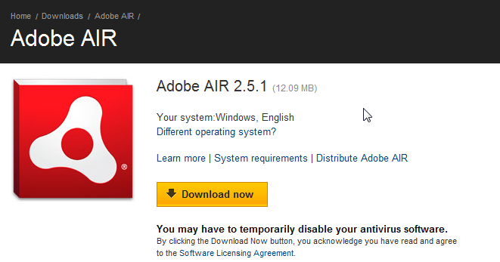

NOTE: Please shutdown the Antivirus software (if required).

### Install

After the completion of the download, “double click” the file to start the installation:-

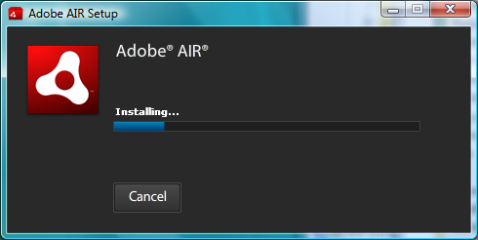

### Install Jbeam-5.6.0.AIR.

“Double click” the Jbeam-5.6.0.air file to start the installation. By default it will get installed within the c:\Program Files.

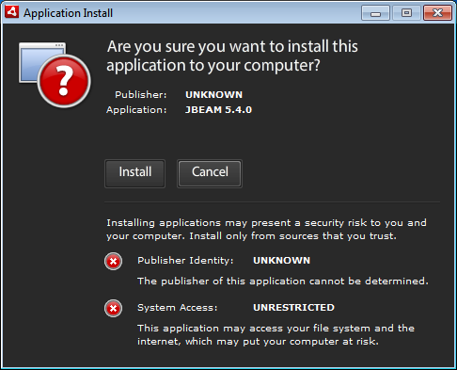

Click on ‘Install’ and the following screen will appear. Click on ‘Continue’ to start the installation.

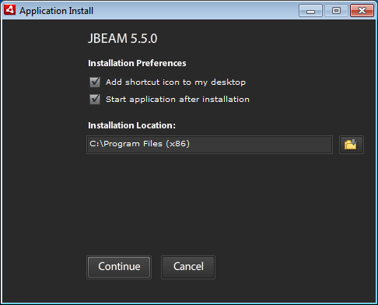

The installation of JBEAM 5.6.0 should finish in less than a minute.

### Configure the server.

Click on the link “Configure Server”. It will open up the Add Server page.

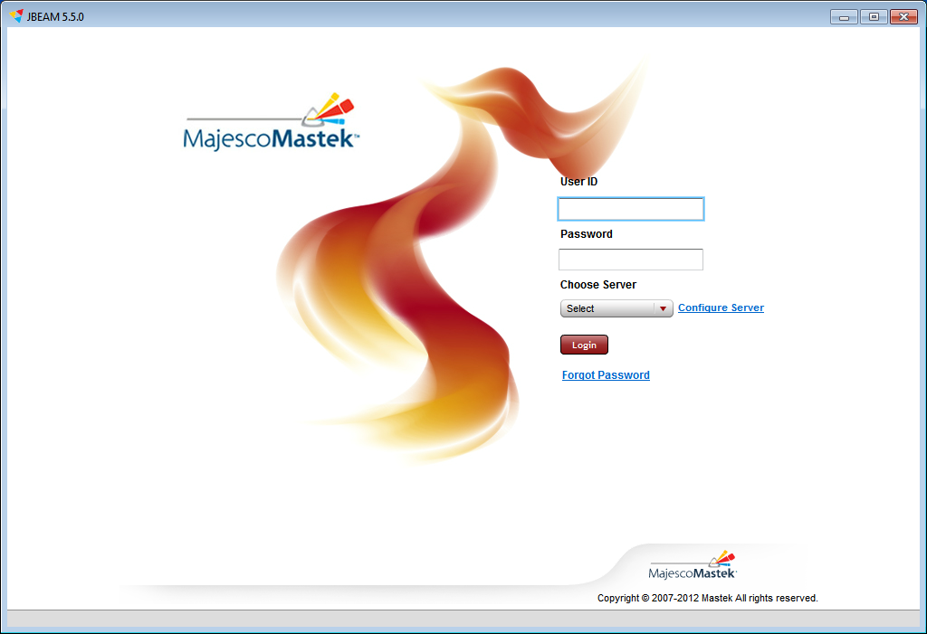

The Add server page helps us to add a Jbeam server to the list. Click on the “Add” button after specifying the correct values for the following parameters:-

**Server Name** : Any unique name e.g. “STG DEMO”

**IP Address** : I.P address of the server on which Jbeam has been installed. (e.g. 172.16.209.165)

**Port**  : 15235 (default port)

* The IP address and the PORT should be same as published by the TIS team.

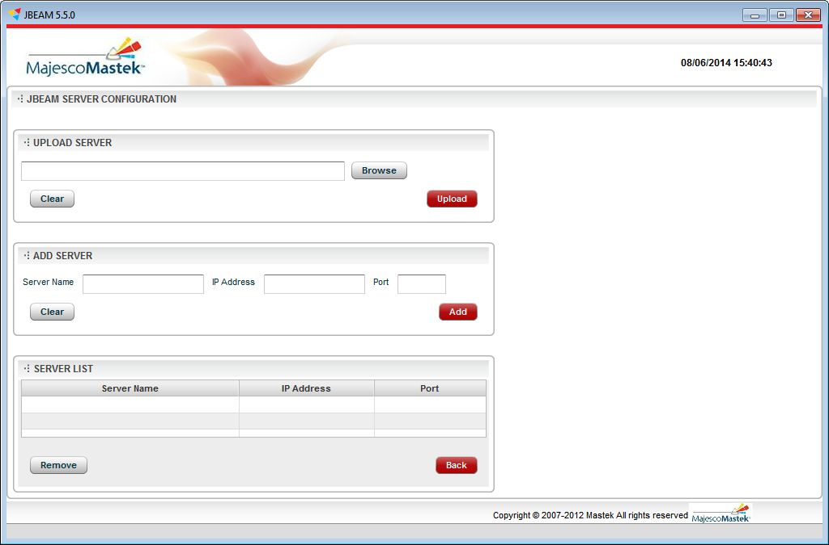

Once the Jbeam server has been added to the list, we should now be able to connect to the server (select “Country POC” from the drop down) using the following credentials:-

Userid: jbeam

Password: test123

## PLUG-INs

### Download plug-ins

This release contains jbeam components with SQL server and PostGre Server compatibility along with Oracle. To implement the functionality plugins are provided.

Download [jbeam-plugins-5.6.0.zip](http://sourceforge.net/projects/jbeam/files/jbeam-plugins/5.6.0/jbeam-plugins-5.6.0.zip/download) from [download](http://sourceforge.net/projects/jbeam/files/jbeam-plugins/5.6.0/) location. Extract the zip file into a local directory.

Refer to following table and deploy the extracted jars in \lib folder of respective component.

|  |  |  |  |
| --- | --- | --- | --- |
|  | Oracle | SQL server | PostGre |
| Monitor-Comm | jbeam-monitor-comm-oracle-5.5.0.jar | jbeam-monitor-comm-mssql-5.5.0.jar | jbeam-monitor-comm-postgre-5.5.0.jar |
| Core Comm | jbeam-core-comm-oracle-5.5.0.jar | jbeam-core-comm-mssql-5.5.0.jar | jbeam-core-comm-postgre-5.5.0.jar |
| PRE | jbeam-core-oracle-5.5.0.jar | jbeam-core-mssql-5.5.0.jar | jbeam-core-postgre-5.5.0.jar |
| Monitor Services | jbeam-monitor-services-oracle-5.5.0.jar | jbeam-monitor-services-mssql-5.5.0.jar | jbeam-monitor-services-postgre-5.5.0.jar |

* This completes the JBEAM installation. Though remember that the framework has been installed now the project specific files must be deployed. Refer to the next section for further details.

## Deploy Project Specific Resources

The following steps are defined as a precaution from the installation perspective and that these may or may not be accompanied during the installation. But it is necessary for the installation manager to ask the details to the project manager who requested to install JBEAM.

### SQL Scripts

The SQL scripts should be taken from the project team for any updates on the default values. Please publish the installation code to the project team and/or otherwise update the existing installation code from the given script file if that differs from the one used above.

### JAR Files

Make sure that you request for any additional jar files from the project team and then deploy them in the PRE lib folder.

### Properties

There might be additional properties that might be required to be added in the PRE properties or any other component of the JBEAM. Make sure that you ask for these values.

Specifically Highlighted

# Appendix

## PRE Verification

Specifically Highlighted

The pre.log file will show something like the following. Note that the logger is set to INFO.

<Tuesday Oct 22, 2013 16:36:34:071><NOTICE><main><Engine>Product Name :Process Request Engine Product Version :30.2.0.0 Bundled On :1375160872297 Build Number :3832

<Tuesday Oct 22, 2013 16:36:34:081><INFO><main><Engine>Initializing Engine

<Tuesday Oct 22, 2013 16:36:34:081><FINEST><main><Engine>Redirecting System.out and System.err to log4j

<Tuesday Oct 22, 2013 16:36:34:082><INFO><main><Engine>CLASSPATH=D:\shantanu\jbeam-5.3.0\PRE30.2/lib/abdera-core-1.0.jar;D:\shantanu\jbeam-5.3.0\PRE30.2/lib/abdera-extensions-json-1.0.jar;D:\shantanu\jbeam-5.3.0\PRE30.2/lib/abdera-extensions-main-1.0.jar;D:\shantanu\jbeam-5.3.0\PRE30.2/lib/abdera-i18n-1.0.jar;D:\shantanu\jbeam-5.3.0\PRE30.2/lib/abdera-parser-1.0.jar;D:\shantanu\jbeam-5.3.0\PRE30.2/lib/activation-1.1.jar;D:\shantanu\jbeam-5.3.0\PRE30.2/lib/ant-optional-1.5.1.jar;D:\shantanu\jbeam-5.3.0\PRE30.2/lib/aopalliance-1.0.jar;D:\shantanu\jbeam-5.3.0\PRE30.2/lib/aspectjrt-1.7.3.jar;D:\shantanu\jbeam-5.3.0\PRE30.2/lib/axiom-api-1.2.7.jar;D:\shantanu\jbeam-5.3.0\PRE30.2/lib/axiom-impl-1.2.7.jar;D:\shantanu\jbeam-5.3.0\PRE30.2/lib/backport-util-concurrent-3.1.jar;D:\shantanu\jbeam-5.3.0\PRE30.2/lib/bcprov-jdk16-1.46.jar;D:\shantanu\jbeam-5.3.0\PRE30.2/lib/com.ibm.icu-3.7.2.jar;D:\shantanu\jbeam-5.3.0\PRE30.2/lib/com.lowagie.text-3.7.2.jar;D:\shantanu\jbeam-5.3.0\PRE30.2/lib/com.majescomastek.stgsuite.icd.service.invoker-5.33.0.jar;D:\shantanu\jbeam-5.3.0\PRE30.2/lib/commons-3.7.2.jar;D:\shantanu\jbeam-5.3.0\PRE30.2/lib/commons-beanutils-1.7.0.jar;D:\shantanu\jbeam-5.3.0\PRE30.2/lib/commons-beanutils-core-1.8.0.jar;D:\shantanu\jbeam-5.3.0\PRE30.2/lib/commons-codec-1.3.jar;D:\shantanu\jbeam-5.3.0\PRE30.2/lib/commons-collections-3.2.1.jar;D:\shantanu\jbeam-5.3.0\PRE30.2/lib/commons-configuration-1.6.jar;D:\shantanu\jbeam-5.3.0\PRE30.2/lib/commons-digester-1.8.jar;D:\shantanu\jbeam-5.3.0\PRE30.2/lib/commons-exec-1.1.jar;D:\shantanu\jbeam-5.3.0\PRE30.2/lib/commons-httpclient-3.1.jar;D:\shantanu\jbeam-5.3.0\PRE30.2/lib/commons-io-1.4.jar;D:\shantanu\jbeam-5.3.0\PRE30.2/lib/commons-jxpath-1.2.jar;D:\shantanu\jbeam-5.3.0\PRE30.2/lib/commons-lang-2.6.jar;D:\shantanu\jbeam-5.3.0\PRE30.2/lib/commons-logging-1.1.1.jar;D:\shantanu\jbeam-5.3.0\PRE30.2/lib/commons-logging-api-1.0.4.jar;D:\shantanu\jbeam-5.3.0\PRE30.2/lib/commons-pool-1.5.5.jar;D:\shantanu\jbeam-5.3.0\PRE30.2/lib/cxf-bundle-2.2.10.jar;D:\shantanu\jbeam-5.3.0\PRE30.2/lib/cxf-bundle-jaxrs-2.2.9.jar;D:\shantanu\jbeam-5.3.0\PRE30.2/lib/cxf-rt-frontend-jaxrs-2.3.2.jar;D:\shantanu\jbeam-5.3.0\PRE30.2/lib/derby-3.7.2.jar;D:\shantanu\jbeam-5.3.0\PRE30.2/lib/dom4j-1.6.1.jar;D:\shantanu\jbeam-5.3.0\PRE30.2/lib/ehcache-core-2.4.5.jar;D:\shantanu\jbeam-5.3.0\PRE30.2/lib/flute-3.7.2.jar;D:\shantanu\jbeam-5.3.0\PRE30.2/lib/geronimo-activation_1.1_spec-1.0.2.jar;D:\shantanu\jbeam-5.3.0\PRE30.2/lib/geronimo-annotation_1.0_spec-1.1.1.jar;D:\shantanu\jbeam-5.3.0\PRE30.2/lib/geronimo-javamail_1.4_spec-1.6.jar;D:\shantanu\jbeam-5.3.0\PRE30.2/lib/geronimo-servlet_2.5_spec-1.2.jar;D:\shantanu\jbeam-5.3.0\PRE30.2/lib/geronimo-stax-api_1.0_spec-1.0.1.jar;D:\shantanu\jbeam-5.3.0\PRE30.2/lib/hazelcast-2.1.2.jar;D:\shantanu\jbeam-5.3.0\PRE30.2/lib/hazelcast-client-2.1.2.jar;D:\shantanu\jbeam-5.3.0\PRE30.2/lib/ICDVO.jar;D:\shantanu\jbeam-5.3.0\PRE30.2/lib/icu4j-2.6.1.jar;D:\shantanu\jbeam-5.3.0\PRE30.2/lib/javax.wsdl-3.7.2.jar;D:\shantanu\jbeam-5.3.0\PRE30.2/lib/jaxb-api-2.1.jar;D:\shantanu\jbeam-5.3.0\PRE30.2/lib/jaxb-impl-2.1.13.jar;D:\shantanu\jbeam-5.3.0\PRE30.2/lib/jaxb-xjc-2.2.1.1.jar;D:\shantanu\jbeam-5.3.0\PRE30.2/lib/jaxb-xjc.jar;D:\shantanu\jbeam-5.3.0\PRE30.2/lib/jaxb2-basics-0.6.0.jar;D:\shantanu\jbeam-5.3.0\PRE30.2/lib/jaxb2-basics-annotate-0.6.0.jar;D:\shantanu\jbeam-5.3.0\PRE30.2/lib/jaxb2-basics-runtime-0.6.0.jar;D:\shantanu\jbeam-5.3.0\PRE30.2/lib/jaxb2-basics-tools-0.6.0.jar;D:\shantanu\jbeam-5.3.0\PRE30.2/lib/jaxen-1.1.1.jar;D:\shantanu\jbeam-5.3.0\PRE30.2/lib/jbeam-commons-5.3.0-SNAPSHOT.jar;D:\shantanu\jbeam-5.3.0\PRE30.2/lib/jbeam-core-5.3.0-SNAPSHOT.jar;D:\shantanu\jbeam-5.3.0\PRE30.2/lib/jbeam-core-oracle-5.3.0-SNAPSHOT.jar;D:\shantanu\jbeam-5.3.0\PRE30.2/lib/jbeamicd-impl-coreprint-billing-5.3.0-SNAPSHOT.jar;D:\shantanu\jbeam-5.3.0\PRE30.2/lib/jbeamicd-impl-jobs-billing-5.3.0-SNAPSHOT.jar;D:\shantanu\jbeam-5.3.0\PRE30.2/lib/jdbcpool-16.6.0.jar;D:\shantanu\jbeam-5.3.0\PRE30.2/lib/jdom-1.1.jar;D:\shantanu\jbeam-5.3.0\PRE30.2/lib/jettison-1.2.jar;D:\shantanu\jbeam-5.3.0\PRE30.2/lib/jetty-6.1.25.jar;D:\shantanu\jbeam-5.3.0\PRE30.2/lib/jetty-continuation-7.2.2.v20101205.jar;D:\shantanu\jbeam-5.3.0\PRE30.2/lib/jetty-http-7.2.2.v20101205.jar;D:\shantanu\jbeam-5.3.0\PRE30.2/lib/jetty-io-7.2.2.v20101205.jar;D:\shantanu\jbeam-5.3.0\PRE30.2/lib/jetty-server-7.2.2.v20101205.jar;D:\shantanu\jbeam-5.3.0\PRE30.2/lib/jetty-util-6.1.25.jar;D:\shantanu\jbeam-5.3.0\PRE30.2/lib/jra-1.0-alpha-4.jar;D:\shantanu\jbeam-5.3.0\PRE30.2/lib/js-3.7.2.jar;D:\shantanu\jbeam-5.3.0\PRE30.2/lib/jsr311-api-1.0.jar;D:\shantanu\jbeam-5.3.0\PRE30.2/lib/log4j-1.2.16.jar;D:\shantanu\jbeam-5.3.0\PRE30.2/lib/mail-1.4.1.jar;D:\shantanu\jbeam-5.3.0\PRE30.2/lib/mysql-connector-java-5.1.25.jar;D:\shantanu\jbeam-5.3.0\PRE30.2/lib/neethi-2.0.4.jar;D:\shantanu\jbeam-5.3.0\PRE30.2/lib/odadesignapi.jar;D:\shantanu\jbeam-5.3.0\PRE30.2/lib/ojdbc14-10.2.0.4.0.jar;D:\shantanu\jbeam-5.3.0\PRE30.2/lib/org.apache.batik.bridge-3.7.2.jar;D:\shantanu\jbeam-5.3.0\PRE30.2/lib/org.apache.batik.css-3.7.2.jar;D:\shantanu\jbeam-5.3.0\PRE30.2/lib/org.apache.batik.dom-3.7.2.jar;D:\shantanu\jbeam-5.3.0\PRE30.2/lib/org.apache.batik.dom.svg-3.7.2.jar;D:\shantanu\jbeam-5.3.0\PRE30.2/lib/org.apache.batik.ext.awt-3.7.2.jar;D:\shantanu\jbeam-5.3.0\PRE30.2/lib/org.apache.batik.parser-3.7.2.jar;D:\shantanu\jbeam-5.3.0\PRE30.2/lib/org.apache.batik.pdf-3.7.2.jar;D:\shantanu\jbeam-5.3.0\PRE30.2/lib/org.apache.batik.svggen-3.7.2.jar;D:\shantanu\jbeam-5.3.0\PRE30.2/lib/org.apache.batik.transcoder-3.7.2.jar;D:\shantanu\jbeam-5.3.0\PRE30.2/lib/org.apache.batik.util-3.7.2.jar;D:\shantanu\jbeam-5.3.0\PRE30.2/lib/org.apache.batik.util.gui-3.7.2.jar;D:\shantanu\jbeam-5.3.0\PRE30.2/lib/org.apache.batik.xml-3.7.2.jar;D:\shantanu\jbeam-5.3.0\PRE30.2/lib/org.apache.commons.codec-3.7.2.jar;D:\shantanu\jbeam-5.3.0\PRE30.2/lib/org.apache.xerces-3.7.2.jar;D:\shantanu\jbeam-5.3.0\PRE30.2/lib/org.apache.xml.resolver-3.7.2.jar;D:\shantanu\jbeam-5.3.0\PRE30.2/lib/org.apache.xml.serializer-3.7.2.jar;D:\shantanu\jbeam-5.3.0\PRE30.2/lib/org.eclipse.birt.runtime-3.7.2.jar;D:\shantanu\jbeam-5.3.0\PRE30.2/lib/org.eclipse.core.contenttype-3.7.2.jar;D:\shantanu\jbeam-5.3.0\PRE30.2/lib/org.eclipse.core.expressions-3.7.2.jar;D:\shantanu\jbeam-5.3.0\PRE30.2/lib/org.eclipse.core.filesystem-3.7.2.jar;D:\shantanu\jbeam-5.3.0\PRE30.2/lib/org.eclipse.core.jobs-3.7.2.jar;D:\shantanu\jbeam-5.3.0\PRE30.2/lib/org.eclipse.core.runtime-3.7.2.jar;D:\shantanu\jbeam-5.3.0\PRE30.2/lib/org.eclipse.datatools.connectivity-3.7.2.jar;D:\shantanu\jbeam-5.3.0\PRE30.2/lib/org.eclipse.datatools.connectivity.apache.derby-3.7.2.jar;D:\shantanu\jbeam-5.3.0\PRE30.2/lib/org.eclipse.datatools.connectivity.apache.derby.dbdefinition-3.7.2.jar;D:\shantanu\jbeam-5.3.0\PRE30.2/lib/org.eclipse.datatools.connectivity.console.profile-3.7.2.jar;D:\shantanu\jbeam-5.3.0\PRE30.2/lib/org.eclipse.datatools.connectivity.db.generic-3.7.2.jar;D:\shantanu\jbeam-5.3.0\PRE30.2/lib/org.eclipse.datatools.connectivity.dbdefinition.genericJDBC-3.7.2.jar;D:\shantanu\jbeam-5.3.0\PRE30.2/lib/org.eclipse.datatools.connectivity.oda-3.7.2.jar;D:\shantanu\jbeam-5.3.0\PRE30.2/lib/org.eclipse.datatools.connectivity.oda.consumer-3.7.2.jar;D:\shantanu\jbeam-5.3.0\PRE30.2/lib/org.eclipse.datatools.connectivity.oda.design-3.7.2.jar;D:\shantanu\jbeam-5.3.0\PRE30.2/lib/org.eclipse.datatools.connectivity.oda.flatfile-3.7.2.jar;D:\shantanu\jbeam-5.3.0\PRE30.2/lib/org.eclipse.datatools.connectivity.oda.profile-3.7.2.jar;D:\shantanu\jbeam-5.3.0\PRE30.2/lib/org.eclipse.datatools.connectivity.sqm.core-3.7.2.jar;D:\shantanu\jbeam-5.3.0\PRE30.2/lib/org.eclipse.datatools.enablement.hsqldb-3.7.2.jar;D:\shantanu\jbeam-5.3.0\PRE30.2/lib/org.eclipse.datatools.enablement.hsqldb.dbdefinition-3.7.2.jar;D:\shantanu\jbeam-5.3.0\PRE30.2/lib/org.eclipse.datatools.enablement.ibm.db2.luw-3.7.2.jar;D:\shantanu\jbeam-5.3.0\PRE30.2/lib/org.eclipse.datatools.enablement.ibm.db2.luw.dbdefinition-3.7.2.jar;D:\shantanu\jbeam-5.3.0\PRE30.2/lib/org.eclipse.datatools.enablement.ibm.informix-3.7.2.jar;D:\shantanu\jbeam-5.3.0\PRE30.2/lib/org.eclipse.datatools.enablement.ibm.informix.dbdefinition-3.7.2.jar;D:\shantanu\jbeam-5.3.0\PRE30.2/lib/org.eclipse.datatools.enablement.msft.sqlserver-3.7.2.jar;D:\shantanu\jbeam-5.3.0\PRE30.2/lib/org.eclipse.datatools.enablement.msft.sqlserver.dbdefinition-3.7.2.jar;D:\shantanu\jbeam-5.3.0\PRE30.2/lib/org.eclipse.datatools.enablement.mysql-3.7.2.jar;D:\shantanu\jbeam-5.3.0\PRE30.2/lib/org.eclipse.datatools.enablement.mysql.dbdefinition-3.7.2.jar;D:\shantanu\jbeam-5.3.0\PRE30.2/lib/org.eclipse.datatools.enablement.oda.ws-3.7.2.jar;D:\shantanu\jbeam-5.3.0\PRE30.2/lib/org.eclipse.datatools.enablement.oda.xml-3.7.2.jar;D:\shantanu\jbeam-5.3.0\PRE30.2/lib/org.eclipse.datatools.enablement.oracle-3.7.2.jar;D:\shantanu\jbeam-5.3.0\PRE30.2/lib/org.eclipse.datatools.enablement.oracle.dbdefinition-3.7.2.jar;D:\shantanu\jbeam-5.3.0\PRE30.2/lib/org.eclipse.datatools.enablement.postgresql-3.7.2.jar;D:\shantanu\jbeam-5.3.0\PRE30.2/lib/org.eclipse.datatools.enablement.postgresql.dbdefinition-3.7.2.jar;D:\shantanu\jbeam-5.3.0\PRE30.2/lib/org.eclipse.datatools.modelbase.dbdefinition-3.7.2.jar;D:\shantanu\jbeam-5.3.0\PRE30.2/lib/org.eclipse.datatools.modelbase.derby-3.7.2.jar;D:\shantanu\jbeam-5.3.0\PRE30.2/lib/org.eclipse.datatools.modelbase.sql-3.7.2.jar;D:\shantanu\jbeam-5.3.0\PRE30.2/lib/org.eclipse.datatools.modelbase.sql.query-3.7.2.jar;D:\shantanu\jbeam-5.3.0\PRE30.2/lib/org.eclipse.emf-3.7.2.jar;D:\shantanu\jbeam-5.3.0\PRE30.2/lib/org.eclipse.emf.common-3.7.2.jar;D:\shantanu\jbeam-5.3.0\PRE30.2/lib/org.eclipse.emf.ecore-3.7.2.jar;D:\shantanu\jbeam-5.3.0\PRE30.2/lib/org.eclipse.emf.ecore.change-3.7.2.jar;D:\shantanu\jbeam-5.3.0\PRE30.2/lib/org.eclipse.emf.ecore.xmi-3.7.2.jar;D:\shantanu\jbeam-5.3.0\PRE30.2/lib/org.eclipse.equinox.app-3.7.2.jar;D:\shantanu\jbeam-5.3.0\PRE30.2/lib/org.eclipse.equinox.common-3.7.2.jar;D:\shantanu\jbeam-5.3.0\PRE30.2/lib/org.eclipse.equinox.preferences-3.7.2.jar;D:\shantanu\jbeam-5.3.0\PRE30.2/lib/org.eclipse.equinox.registry-3.7.2.jar;D:\shantanu\jbeam-5.3.0\PRE30.2/lib/org.eclipse.osgi-3.7.2.jar;D:\shantanu\jbeam-5.3.0\PRE30.2/lib/org.eclipse.osgi.services-3.7.2.jar;D:\shantanu\jbeam-5.3.0\PRE30.2/lib/org.eclipse.update.configurator-3.7.2.jar;D:\shantanu\jbeam-5.3.0\PRE30.2/lib/org.w3c.css.sac-3.7.2.jar;D:\shantanu\jbeam-5.3.0\PRE30.2/lib/org.w3c.dom.smil-3.7.2.jar;D:\shantanu\jbeam-5.3.0\PRE30.2/lib/org.w3c.dom.svg-3.7.2.jar;D:\shantanu\jbeam-5.3.0\PRE30.2/lib/oro-2.0.8.jar;D:\shantanu\jbeam-5.3.0\PRE30.2/lib/pre-30.2.0.0.jar;D:\shantanu\jbeam-5.3.0\PRE30.2/lib/pre-birt-plugin-1.1.0.jar;D:\shantanu\jbeam-5.3.0\PRE30.2/lib/saaj-api-1.3.jar;D:\shantanu\jbeam-5.3.0\PRE30.2/lib/saaj-impl-1.3.2.jar;D:\shantanu\jbeam-5.3.0\PRE30.2/lib/saaj.jar;D:\shantanu\jbeam-5.3.0\PRE30.2/lib/scriptapi.jar;D:\shantanu\jbeam-5.3.0\PRE30.2/lib/serializer-2.7.1.jar;D:\shantanu\jbeam-5.3.0\PRE30.2/lib/servlet-api-2.2.jar;D:\shantanu\jbeam-5.3.0\PRE30.2/lib/slf4j-api-1.6.1.jar;D:\shantanu\jbeam-5.3.0\PRE30.2/lib/slf4j-nop-1.7.5.jar;D:\shantanu\jbeam-5.3.0\PRE30.2/lib/Spi-5.16.jar;D:\shantanu\jbeam-5.3.0\PRE30.2/lib/spring-aop-3.0.5.RELEASE.jar;D:\shantanu\jbeam-5.3.0\PRE30.2/lib/spring-asm-3.0.5.RELEASE.jar;D:\shantanu\jbeam-5.3.0\PRE30.2/lib/spring-beans-3.0.5.RELEASE.jar;D:\shantanu\jbeam-5.3.0\PRE30.2/lib/spring-context-3.0.5.RELEASE.jar;D:\shantanu\jbeam-5.3.0\PRE30.2/lib/spring-context-support-3.0.5.RELEASE.jar;D:\shantanu\jbeam-5.3.0\PRE30.2/lib/spring-core-3.0.5.RELEASE.jar;D:\shantanu\jbeam-5.3.0\PRE30.2/lib/spring-expression-3.0.5.RELEASE.jar;D:\shantanu\jbeam-5.3.0\PRE30.2/lib/spring-jdbc-3.0.5.RELEASE.jar;D:\shantanu\jbeam-5.3.0\PRE30.2/lib/spring-test-3.0.5.RELEASE.jar;D:\shantanu\jbeam-5.3.0\PRE30.2/lib/spring-tx-3.0.5.RELEASE.jar;D:\shantanu\jbeam-5.3.0\PRE30.2/lib/spring-web-2.5.6.jar;D:\shantanu\jbeam-5.3.0\PRE30.2/lib/spring-web-3.0.5.RELEASE.jar;D:\shantanu\jbeam-5.3.0\PRE30.2/lib/stax2-api-3.0.2.jar;D:\shantanu\jbeam-5.3.0\PRE30.2/lib/stg-birt-1.3.5.jar;D:\shantanu\jbeam-5.3.0\PRE30.2/lib/stg-commons-1.13.0.jar;D:\shantanu\jbeam-5.3.0\PRE30.2/lib/Tidy-3.7.2.jar;D:\shantanu\jbeam-5.3.0\PRE30.2/lib/truelicense-core-1.33.jar;D:\shantanu\jbeam-5.3.0\PRE30.2/lib/truelicense-xml-1.33.jar;D:\shantanu\jbeam-5.3.0\PRE30.2/lib/wsdl4j-1.6.2.jar;D:\shantanu\jbeam-5.3.0\PRE30.2/lib/wstx-asl-3.2.9.jar;D:\shantanu\jbeam-5.3.0\PRE30.2/lib/xalan-2.6.0.jar;D:\shantanu\jbeam-5.3.0\PRE30.2/lib/xercesImpl-2.6.2.jar;D:\shantanu\jbeam-5.3.0\PRE30.2/lib/xml-apis-1.0.b2.jar;D:\shantanu\jbeam-5.3.0\PRE30.2/lib/xmlbeans-2.4.0.jar;D:\shantanu\jbeam-5.3.0\PRE30.2/lib/xmlParserAPIs-2.6.2.jar;D:\shantanu\jbeam-5.3.0\PRE30.2/lib/XmlSchema-1.4.5.jar;D:\shantanu\jbeam-5.3.0\PRE30.2/lib/xom-1.0.jar;;;

<Tuesday Oct 22, 2013 16:36:34:097><INFO><main><Engine>Add ShutDown Hook ....

<Tuesday Oct 22, 2013 16:36:34:097><INFO><main><Engine>ShutDown Hook Added....

<Tuesday Oct 22, 2013 16:36:34:097><INFO><main><Engine>Initializing Connection Pool ....

<Tuesday Oct 22, 2013 16:36:34:109><INFO><main><stg.pr.engine.datasource.defaultimpl.PREDataSourceFactory>Initializing the DataSourceFactory...

<Tuesday Oct 22, 2013 16:36:34:684><DEBUG><main><jdbc.pool.CXMLManager>Reading attributes for pool #ST

<Tuesday Oct 22, 2013 16:36:35:954><DEBUG><main><jdbc.pool.CXMLManager>Pool Attributes read for pool #ST

<Tuesday Oct 22, 2013 16:36:35:955><DEBUG><main><jdbc.pool.CXMLManager>Reading attributes for pool #BATCH

<Tuesday Oct 22, 2013 16:36:35:958><DEBUG><main><jdbc.pool.CXMLManager>Pool Attributes read for pool #BATCH

<Tuesday Oct 22, 2013 16:36:35:958><DEBUG><main><jdbc.pool.CXMLManager>Reading attributes for pool #APPLICATION

<Tuesday Oct 22, 2013 16:36:35:960><DEBUG><main><jdbc.pool.CXMLManager>Pool Attributes read for pool #APPLICATION

<Tuesday Oct 22, 2013 16:36:35:961><INFO><main><stg.pr.engine.datasource.defaultimpl.PREDataSourceFactory>DataSourceFactory Initialized properly..

<Tuesday Oct 22, 2013 16:36:35:966><INFO><main><Engine>Initiating the cluster using the configuration from file D:/shantanu/jbeam-5.3.0/PRE30.2/resources/hazelcast.xml

<Tuesday Oct 22, 2013 16:36:42:623><INFO><main><Engine>Service ReportGenerator:com.mmpnc.pre.plugins.ReportServicemade available to the context..

<Tuesday Oct 22, 2013 16:36:42:623><NOTICE><main><Engine>Starting Web Services

<Tuesday Oct 22, 2013 16:36:42:625><INFO><Thread-4><WebServer>Acquiring Port #15004

<Tuesday Oct 22, 2013 16:36:42:629><INFO><main><Engine>Engine Initialized

<Tuesday Oct 22, 2013 16:36:42:629><NOTICE><Thread-4><WebServer>Web Server Started and is listening on 15004

<Tuesday Oct 22, 2013 16:36:42:629><INFO><main><Engine>Starting the Engine..

<Tuesday Oct 22, 2013 16:36:42:710><NOTICE><main><Engine>PRE is configured for cluster mode on 2 different machines.

<Tuesday Oct 22, 2013 16:36:42:710><NOTICE><main><Engine>Going into RUNNING mode.

<Tuesday Oct 22, 2013 16:36:42:738><DEBUG><main><Mailer>Setting default message footer

<Tuesday Oct 22, 2013 16:36:42:739><DEBUG><main><Mailer>Getting default message header

<Tuesday Oct 22, 2013 16:36:42:750><INFO><main><Mailer>0 emails loaded. Queueing emails..

<Tuesday Oct 22, 2013 16:36:42:750><INFO><main><Mailer>Emails queued for tranport.

<Tuesday Oct 22, 2013 16:36:42:751><INFO><main><Engine>Initializing JOB Monitor...

<Tuesday Oct 22, 2013 16:36:42:751><NOTICE><grpeng><Engine>Group Engine Not Started. To Start the group engine have the value of the groupengine property to ON

<Tuesday Oct 22, 2013 16:36:42:752><NOTICE><grpeng><Engine>Group Engine stopped.. Wait till PRE terminates.

<Tuesday Oct 22, 2013 16:36:42:754><NOTICE><main><Engine>Start Service Engine for Stand Alone Requests....

<Tuesday Oct 22, 2013 16:36:42:754><INFO><main><Engine>Starting StandAlone Engine ....

<Tuesday Oct 22, 2013 16:36:42:755><INFO><main><Engine>Getting JDBC Connection for the StandAlone Engine ....

<Tuesday Oct 22, 2013 16:36:42:754><NOTICE><JobMonitorThread><JobMonitor>Started...

<Tuesday Oct 22, 2013 16:36:42:755><DEBUG><main><stg.pr.engine.datasource.defaultimpl.PREDataSourceFactory>Fetching DataSource #ST

<Tuesday Oct 22, 2013 16:36:42:756><INFO><JobMonitorThread><JobMonitor>Will sleep for 2 minute(s).

<Tuesday Oct 22, 2013 16:36:42:763><INFO><main><JDBC.Pool[ST]>Using First-In-First-Out Algorithm

<Tuesday Oct 22, 2013 16:36:42:919><DEBUG><main><JDBC.Pool[ST]>Attempting number of #1 new JDBC Connections

<Tuesday Oct 22, 2013 16:36:43:248><DEBUG><main><JDBC.Pool[ST]>New Connection Created #oracle.jdbc.driver.T4CConnection@17b0b76

<Tuesday Oct 22, 2013 16:36:43:248><DEBUG><main><JDBC.Pool[ST]>Adding Connection to the pool #oracle.jdbc.driver.T4CConnection@17b0b76

<Tuesday Oct 22, 2013 16:36:43:249><DEBUG><main><JDBC.Pool[ST]>Initiate Self Check background process

<Tuesday Oct 22, 2013 16:36:43:251><INFO><main><JDBC.Pool[ST]>Pool will not be shrinked nor self checks will be initiated.

<Tuesday Oct 22, 2013 16:36:43:258><NOTICE><main><JDBC.Pool[ST]>Pool Created and initialized. Statstics Pool Started On,1382440002763, Connections High,0, Leaked ResultSet,0, Leaked Statements,0, Leaked Connections,0, Current Used Connections,0, Current Free Connections,1, Bad Connections Found,0, Current Waiters,0, Waiters High,0, Wait Time High,0, Total Wait Time,0, Average Connection Delay,328, Connections Total,1, Unavailable Connections,0, Unavailable Connections High,0, Unavailable Connections High Time,0, Used Memory,30042112, Total Memory,66715648, HeapMemoryUsed,30042112, HeapMemoryMax,1065484288, NonHeapMemoryUsage,20703624, NonHeapMemoryMax,100663296

<Tuesday Oct 22, 2013 16:36:43:259><DEBUG><main><JDBC.Pool[ST]>{0}Validating the Connection object.

<Tuesday Oct 22, 2013 16:36:43:364><DEBUG><main><JDBC.Pool[ST]>Connection found OK.

1. The driver must match to that of the database version. In other words, use the same JDBC driver that came along with Oracle database.